PNEUMONIA DETECTION USING COMPUTER VISION

A PROJECT REPORT

BY

TEAM NO. 4

ANWESH BADAPANDA (E19CSE058)

TANUJ SHARMA (E19CSE147)

SUBMITTED TO

DEPARTMENT OF COMPUTER SCIENCE ENGINEERING BENNETT UNIVERSITY

GREATER NOIDA, 201310, UTTAR PRADESH, INDIA

NOVEMBER 2020

# DECLARATION

I/We hereby declare that the work which is being presented in the report entitled “Pneumonia Detection using Computer Vision”, is an authentic record of my/our own work carried out during the period from JUNE, 2020 to November, 2020 at Department of Computer Science and Engineering, Bennett University Greater Noida.

The matters and the results presented in this report has not been submitted by me/us for the award of any other degree elsewhere.

Signature of Candidate

Anwesh Badapanda

(Enroll. No. E19CSE058)

Tanuj Sharma

(Enroll. No. E19CSE147)

Tarun Laxmipat Lunia

(Enroll. No. E19CSE004)

# ACKNOWLEDGEMENT

We would like to take this opportunity to express my/our deepest gratitude to my/our mentor, **Dr Tapas Kumar Badal** for guiding, supporting, and helping me/us in every possible way. We were extremely fortunate to have him as our mentor as he provided insightful solutions to problems faced by me/us thus contributing immensely towards the completion of this capstone project. We would also like to express our deepest gratitude to VC, DEAN, HOD, faculty members and friends who helped us in successful completion of this capstone project.

Signature of Candidate

Anwesh Badapanda

(Enroll. No. E19CSE058)

Tanuj Sharma

(Enroll. No. E19CSE147)

Tarun Laxmipat Lunia

(Enroll. No. E19CSE004)

**TABLE OF CONTENTS**

ACKNOWLEDGEMENTS iii

TABLE OF CONTENTS…………………………………………………………………………iv

LIST OF TABLES vi

LIST OF FIGURES viiii

LIST OF ABBREVIATIONS viii

ABSTRACT ix

1. INTRODUCTION 1

1.1. Problem Statement 1

2. Background Research 2

2.1. Proposed System 3

2.2. Goals and Objectives 3

3. Project Planning 4

3.1. Project Lifecycle 4

3.2. Project Setup 4

3.3. Stakeholders 5

3.4. Project Resources 5

3.5. Assumptions 5

4. Project Tracking 6

4.1. Tracking 5

4.2. Communication Plan 6

4.3. Deliverables 7

5. SYSTEM ANALYSIS AND DESIGN 7

5.1. Overall Description 7

5.2. Users and Roles 8

5.3. Design diagrams/ UML diagrams/ Flow Charts/ E-R diagrams 9

5.3.1. Flow Chart 9

6. User Interface 10

6.1. UI Description 10

6.2. UI Mockup 11

7. Algorithms/Pseudo Code 12

8. Project Closure 12

8.1. Goals / Vision 12

8.2. Delivered Solution 13

8.3. Remaining Work 13

REFERENCES 14

**LIST OF TABLES**

Table Page

Table 1: Goal and Objectives 4

Table 2: Decision Description 4

Table 3: Stakeholders 5

Table 4: Project Resources 5

Table 5: Assumption 5

Table 6: Tracking 6

Table 7: Regularly Scheduled Meetings 6

Table 8: Information To Be Shared Within Our Group 6

Table 9: Information To Be Provided To Other Groups 7

Table 10: Deliverables 7

Table 11: User Roles 8

**LIST OF FIGURES**

Figure Page

Figure 1: Use Flowchart 9

Figure 2 : UI Design 11

**LIST OF ABBREVIATIONS**

Abbreviation Explanation of the Abbreviation

CBC Complete Blood Count

CT Computed Topography

X-Ray X-Radiation

CNN Convolutional Neural Network

RGB Red Green Blue

ReLU Rectified Linear Unit

**ABSTRACT**

The current pandemic is just another example of how important it is to quickly diagnose a highly contagious disease. Pneumonia too is a highly contagious disease and while there exist vaccines to protect people against this disease, testing can still be expensive. Usually the diagnosis can be done via a CBC test, a CT scan and X-Rays. Usually X-Rays are the best form of initial testing for Pneumonia because these are both cheap, quick and accurate. However, this process can sometimes still become slow and hectic, because these X-Rays have to be manually examined.

In this project we propose a system in which an X-Ray scan of the patient’s lungs can be uploaded and the system, using deep learning algorithms, tests and provides a pneumonia diagnosis. The doctors, who we aim to be our end users, can upload multiple scans through this system and also check the results that the system has produced in the past.

The neural networks designed by us, provide an overall accuracy of about 88 percent. This accuracy however, is slightly higher at around 93 percent, when we consider scans which indicate the presence of pneumonia in the body.

This system would be highly effective in clinics and hospitals, especially those with inadequate staff and limited budgets. This would save lots of time in diagnosis while still being cheap.

1. **INTRODUCTION**

Currently pneumonia diagnosis is usually done in the following way :-

* A person with experiencing chest pain, persistent fever, difficulty in breathing visits a doctor.
* If the doctor is unable to find any other explanation for the above-mentioned symptoms, he/she recommends a chest x-ray to the patient.
* If the doctor notices sign of inflammation in the lungs through the X-Rays, the doctor checks the patient’s blood oxygen level and if it's below a specific threshold, the doctor recommends admitting the patient into the hospital/clinic and prescribes many more tests to find out the extent and seriousness of the disease.

With our project we think we can speed up this process by automating analysis of the X-Rays. Doctors will be able to upload images of X-Ray scans to our website and get diagnosis of the scan almost instantaneously. They can login using their credentials and the results of the previous scans will be saved to their account.

1.1 **Problem Statement**

Currently, in most hospitals and clinics, the chest X-ray scans are analyzed manually. This leads to slow diagnosis and sometimes contributes to further infections, especially in institutions which have limited budgets and/or are understaffed in comparison to the patients they have. Currently, it takes a while to get back the test results due to which leads to slower diagnosis and sometimes even leads to the patient having to spend money on additional tests, so that the preliminary test results and other test results arrive at the same time. Manually examining the X-Rays also leads to additional workload on doctors for a simple task which can be automated. The availability of a website in which images can be uploaded and results can be retrieved in a simple way, will be very beneficial for patients, doctors, clinics and hospitals.

1. **Background Research**

In India alone, there are about 0.56 million cases of pneumococcal pneumonia and about 105 thousand pneumococcal deaths[[1]](https://www.ncbi.nlm.nih.gov/pmc/articles/PMC4472804/). Children under the age of 5 are the most affected by these deaths as they suffer almost 800,000 deaths per year, and 2000 per day[[2]](https://stoppneumonia.org/wp-content/uploads/2019/11/India-12.11.2019-Web.pdf).

In India, the following procedure is followed to diagnose a case of pneumonia. If a patient is suffering from symptoms like cough, shortness of breath, chess pain with fever, chills, they visit a healthcare facility. The doctors, using a chest X-Ray, doctors search for signs like lobar/patchy consolidation, cardiac or diaphragmatic silhouette etc. If these signs are present and aren’t due to other causes, a score called the CRB-65 score is calculated using the confusion, respiratory rate, blood pressure and the age of the patient. If the score is above 1, the patient is directly admitted to a healthcare facility, if not, the oxygen saturation is checked using pulse oximetry. If the oxygen saturation is less than 92% for patients under 50 years of age or under 90% for patients over the age of 50, they are admitted to a healthcare facility, else they are managed on an outpatient basis, i.e. they are advised to take certain measures and medications, but are not admitted a healthcare facility[[3]](https://lungindia.com/article.asp?issn=0970-2113;year=2012;volume=29;issue=6;spage=27;epage=62;aulast=Gupta;type=3).

Depending on the urgency of the case, getting the results of a X-Ray scan can take between a few minutes, to a couple of hours[[4]](https://www.healthlinkbc.ca/medical-tests/hw205975#:~:text=In%20an%20emergency%2C%20the%20results,in%201%20or%202%20days.&text=Normal%3A,the%20lung%20tissue%20looks%20normal.). Usually it’s the responsibility of a radiologist, to take a look at X-Rays, interpret results from them and then write detailed reports[[5]](https://www.radiologyinfo.org/en/info.cfm?pg=article-your-radiologist).

Now that we know about the problem, we must look for a way to solve this problem. An obvious choice would be using a website which could be accessed by registered members, where they could upload images and get results quickly. But how would we classify images into their respective groups?

CNNs are the default choices in the task of image classification[[6]](http://yann.lecun.com/exdb/publis/pdf/lecun-98.pdf) even in complex tasks like pneumonia detection[[7]](https://papers.nips.cc/paper/2012/file/c399862d3b9d6b76c8436e924a68c45b-Paper.pdf). With the help of a large enough dataset, and a sufficiently powerful GPU, iterating over many models and selecting an ideal model becomes easy.

But how does a CNN work? We know that every image is made out of pixels, so to help the machine differentiate between the features in different categories of images, first an image is converted into a multidimensional array(depending on the colortype of the image) consisting of the intensity of its RGB/Black and White values. Now the next step is to fit the images into the network. In a CNN the network consists of convolutional layers, fully connected layers and pooling layers. When the image array is passed into the convolutional layer, the image is convoluted over, by applying a filter which is basically a block of numbers, over the array. This gives us the convolved feature map also known as activation map which is smaller than the original image. This makes it faster and easier for the computer to deal with. Usually after this we apply a pooling layer.A pooling layer can either be max pool or average pool. In max pool we select the max value over the pooling size, in average pool we select the average value over the pooling size and make a new feature map with those values. Usually we repeat the combination of convolutional layer and pooling layer for a few times depending on the size of the image. Finally we apply the fully connected layer, which is connected to the final layer from which produces the prediction. The convolutional layers and fully connected have different weights and biases in each neuron. The weights are multiplied to the input from the previous layer and the biases are added to the product. These values are adjusted to produce the correct predictions depending on our training data. Each layer also has its activation function which is applied to the pre-final result of the layer. Activation functions applied to add non-linearity to the data. The most efficient activation layer in most cases is ReLU activation function, and the activation function applied to the final fully connected layer depends on the number of neurons we have in the last layer[[8]](https://towardsdatascience.com/wtf-is-image-classification-8e78a8235acb#:~:text=A%20CNN%20convolves%20(not%20convolutes,ideal%20for%20processing%202D%20images.&text=This%20means%20that%20they%20can,hand%2Dmade%20in%20other%20algorithms.). If we have only 1, we use the sigmoid activation function. If we have multiple, we use the softmax activation function[[9]](https://towardsdatascience.com/deep-learning-which-loss-and-activation-functions-should-i-use-ac02f1c56aa8) .

2.1 **Proposed System**

This project aims at helping doctors detect cases of pneumonia in patients, using chest X-Rays. We intend to do this by deploying deep learning models on a flask based website where doctors will be able to upload images of X-Ray scans and get results. This will help doctors quickly diagnose affected patients and help them save time, especially when they are dealing with more patients than usual.

2.2 **Goals and Objectives**

**Table 1: Goal and Objectives**

|  |  |
| --- | --- |
| **#** | **Goal or Objective** |
| 1 | Provide a fast and smooth user experience |
| 2 | Make accurate predictions |
| 3 | Make a simple UI |

1. **Project Planning**

This section covers the details of the project planning. Selecting the lifecycle of the development, project stakeholders, resources required, assumptions made (if any) are detailed in the sections below.

3.1 **Project Lifecycle**

The team will use an agile approach. Our team will gather requirements and create a high level development plan at the onset of the project and then implement the gathered requirements over three iterations. The team will follow a SCRUM-like approach with an emphasis on frequent meetings and collaboration.

3.2 **Project Setup**

**Table 2 : Decision Description**

|  |  |
| --- | --- |
| **#** | **Decision Description** |
| 1 | Windows 10, MacOS, VSCode, Jupyter Notebook, HTML, CSS, JavaScript, Flask, Git, SQL |
| 2 | PEP8 Coding Standard for Python |

3.3 **Stakeholders**

**Table 3: Stakeholders**

|  |  |
| --- | --- |
| **Stakeholder** | **Role** |
| Tapas Badal | Course Coordinator |
| Deepak Garg | Mentor |
| Tanuj Sharma | Team member |
| Tarun Laxmipat Lunia | Team member |
| Anwesh Badapanda | Team member |

3.4 **Project Resources**

**Table 4: Project Resources**

|  |  |  |
| --- | --- | --- |
| **Resource** | **Resource Description** | **Quantity** |
| Capstone Team | Our team of 3 students who will be the developers of the project. | 1 |
| Computers | Each member must have a computer irrespective of Operating System to contribute in the development of the project. | 3 |
| Mobile Phones | Each team member must also have a mobile phone to ensure effective communication. | 3 |
| GPU | A GPU will be be needed for faster training of the deep learning models | 1 |
| Dataset | A labelled dataset of images of X-Ray scans will be needed to train the deep learning models | 1 |

3.5 **Assumptions**

**Table 5: Assumptions**

|  |  |
| --- | --- |
| **#** | **Assumption** |
| A1 | The capstone team will be able to ensure quick communication with each other. |
| A2 | The team will be able to meet via video calls when before submission of project documentation |
| A3 | Team members will be able to learn the technologies/frameworks that are needed to perform their role in the project |
| A4 | The Deep Learning models will provide satisfactory accuracies |
| A5 | The dataset being used is properly labelled |
| A6 | The project dependencies/libraries will remain functional |

1. **Project Tracking**

4.1 **Tracking**

**Table 6: Tracking**

|  |  |  |
| --- | --- | --- |
| **Information** | **Description** | **Link** |
| Code Storage | Project code will be stored in GitHub repository. | [Link](https://github.com/anweshb/PDuCV) |
| Project Documents and Assignments | All milestone documents will be stored in the same GitHub repository as above | [Link](https://github.com/anweshb/PDuCV) |
| Bugs and error tracking | All the bugs and errors will be tracked using the default IDE. | [Link](https://code.visualstudio.com/) |

4.2 **Communication Plan**

**Table 7: Regularly Scheduled Meetings**

|  |  |  |
| --- | --- | --- |
| **Meeting Type** | **Frequency/Schedule** | **Who Attends** |
| Conference Call/MS Teams | Weekly | Project team and mentor/course coordinator |
| Team meetings and discussions | Bi-Weekly | Project team |
| Live Sessions | Weekly | Whole batch and industry experts |

**Table 8: Information To Be Shared Within Our Group**

|  |  |  |  |
| --- | --- | --- | --- |
| **Who?** | **What Information?** | **When?** | **How?** |
| Project team | Task assignments & updates | Bi - weekly | WhatsApp chats/ Google Meetings |

**Table 9: Information To Be Provided To Other Groups**

|  |  |  |  |
| --- | --- | --- | --- |
| **Who?** | **What Information?** | **When?** | **How?** |
| Mentor and Course Coordinator | Final deliverables | At completion of project | Project specification doc., code, Power Point presentation |
| Mentor/Course Coordinator | Weekly report | Weekly | Email and Trac site access |

4.3 **Deliverables**

**Table 10: Deliverables**

|  |  |
| --- | --- |
| **#** | **Deliverable** |
| 1 | Code |
| 2 | Working website |
| 3 | Postmortem document |
| 4 | Final report (final PowerPoint presentation, 3 minute video, and final sprint) |

1. **SYSTEM ANALYSIS AND DESIGN**

This section describes in detail about the design part of the system.

5.1 **Overall Description**

The project is an attempt to bring technology like Flask Framework, Python, CSS, and JavaScript to the medical field that is for long wanting a change or a revolution to be precise. It hits on three different points that made this idea our clear choice and which are: the idea should be monetizable, should be expandable in terms of technology, and should have a major social impact in any field.

The final solution involves detecting Pneumonia by using chest-x-ray images of people who have tested positive and negative for pneumonia through computer vision techniques. We used training data which had around about 4000 images, 600 validation, and testing images each. Depending on the computational time we deployed multiple pruned models on a Flask web-app to minimize the chances of getting incorrect predictions. Pruning the models decreased the size of the model by removing parameters which make very little to no contribution to our predictions.

The user will have the ability to login to their account and upload chest x-ray images and check the results that will also be saved if the user wants to check them at a later time which will save both time and energy of the working professional

5.2 **Users and Roles**

**Table 11: User Roles**

|  |  |
| --- | --- |
| **User** | **Description** |
| UI Designer | A capstone team member who is responsible for creating an UI mockup as well as frontend part of the website while keeping in mind about the user accessibility and experience. |
| Document keeper | The fellow team member will handle all the documentation part as well as handling the social media presence of the project |
| Backend part | Two members will handle the backend part of the project which include creating different deep learning models and pruning them along with creating a backend with the help of flask where the models are deployed. |

5.3 **Design diagrams/ UML diagrams/ Flow Charts/ E-R diagrams**

5.3.1 **Flow Chart**

**Figure 1: Use Flowchart**

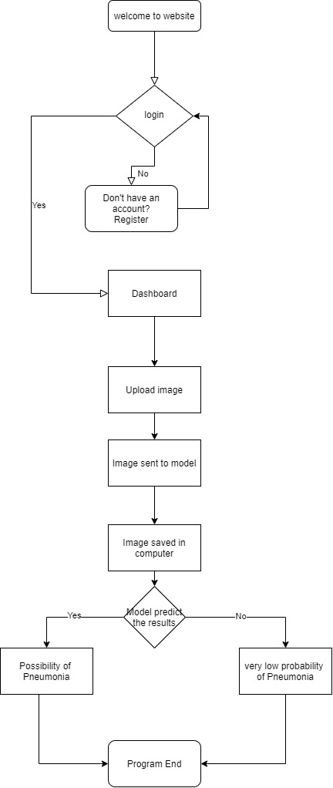

1. **User Interface** 
   1. **UI Description**

We are creating a project related to the medical field, so we gave a great emphasis on having a UI/UX that is pleasant to the mind of the users and has a simplistic approach when coming to arrangements and color choice.Our Interface has many rounds of creation like creating one on Adobe XD, taking feedback from the real users, and then making suitable changes.

The overall consistent feel on the website was achieved by keeping the same color palette, fonts, and overall design. It provides adequate feedback so that the user is assured that their actions have been executed or not. It also uses simple and natural dialogue for the user to see only relevant information that is essential for task completion.

* 1. **UI Mockup**

**Figure 2: UI Design**

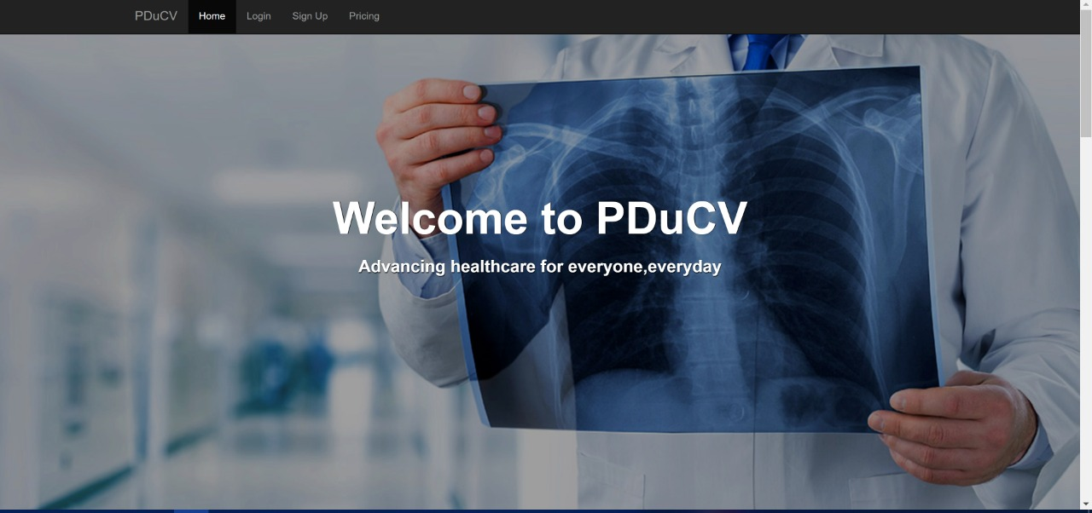

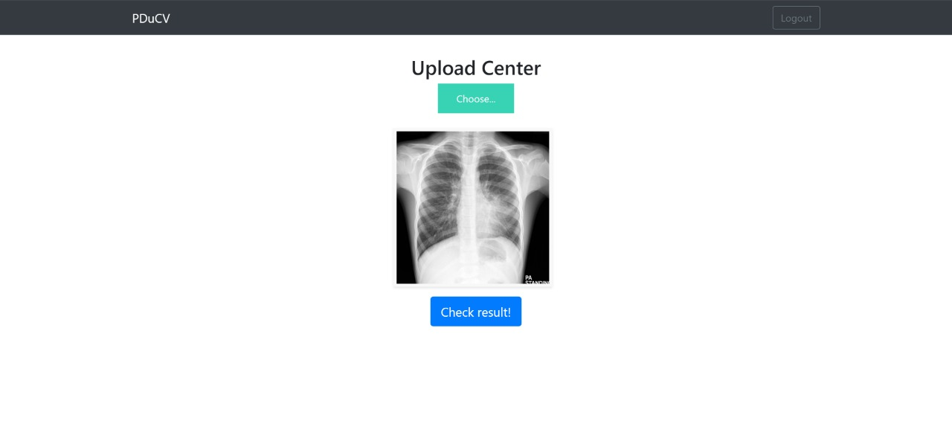

1. **Algorithms/Pseudo Code**

BEGIN

#User enters the platform.

if the User is not a registered member THEN .

User will register on the Register Tab

The user will log in.

#User will be redirected to the Dashboard.

` User selects Upload an image option.

User Uploads an image THEN

The image is scanned by the models.

An Output is predicted with the probability of occurrence of pneumonia.

else

The user will log in.

#User will be redirected to the Dashboard.

` User selects Upload an image option.

User Uploads an image THEN

The image is scanned by the models.

An Output is predicted with the probability of occurrence of pneumonia.

END

1. **Project Closure**

This section elucidates the overall lookup at the project and some of the future works that may enhance the solution.

* 1. **Goals/Vision**

Our goal at the beginning of the project was to provide a working website for doctors, where they could upload images of chest X-Ray scans and this website would predict if the X-Ray scan in question has any visible signs of pneumonia. This was supposed to be done by training deep learning models on available data using Python and TensorFlow, and selecting three such models with high accuracy and hosting them on our flask based website. Out of those three, the result predicted by at-least two of these models would be accepted and shown to the doctor. As the project progressed, we realized the importance of relevant documentation and demonstrations and worked on that as well, in addition to our original goal.

* 1. **Delivered Solution**

Our solution consists of everything we aimed for. We were able to make 3 deep learning models with high accuracy with even higher accuracy on positive scans, meaning the chances of our model making false negative errors are very low. We were able to make a working website which hosts the 3 models, accepts X-Ray scan images, predicts the output and stores the result in the doctor’s account.

* 1. **Remaining Work**

We would like to expand the dataset we trained our model on and try to get higher general accuracy. In addition, we want to provide users with the options of uploading different types of scans in addition to X-Rays like CT scans in formats like TIFF and DIMCOM. We would also like to keep improving the UI of the website.

**REFERENCES**

1. Habib Foorqui, Mark Jit, David L. Heyman, Sanjay Zodpey. Burden of Severe Pneumonia, Pneumococcal Pneumonia and Pneumonia Deaths in Indian States: Modelling Based Estimates PLOS One. p. 1, 2015

2. Stoppneumonia.org. Fighting for Breath in India. p. 1, 2019

3. Dheeraj Gupta, Ritesh Agarwal, Ashutosh Nath Aggatwal, Navneet Singh et al. Guidelines for diagnosis and management of community-and hospital-acquired pneumonia in adults: Joint ICS/NCCP(I) recommendations. Lung India. p. 2, 2012

4. Healthwise Staff. Chest X-Ray Test Overview. HealthLink BC. 2019

5. RadiologyInfo.org. What does a radiologist do? Radiological Society of North America. 2019

6. Yann LeCun, Leon Bottou, Yoshua Bengio and Patrick Haffner. Gradient-Based Learning Applied to Document Recognition. IEEEexplore. 1998.

7.Alex Krizhevsky, Ilya Sutskever and Geoffrey E. Hinton. ImageNet Classification with Deep Convolutional Neural Networks. Communications of the ACM. Conference on Neural Information Processing Systems. p. 8. 2012.

8. Anne Bonner. The Complete Beginner’s Guide to Deep Learning: Convolutional Neural Networks and Image Classification. Towards Data Science. 2019

9. Stacey Ronaghan. Deep Learning: Which Loss and Activation Functions should I use? Towards Data Science. 2018.